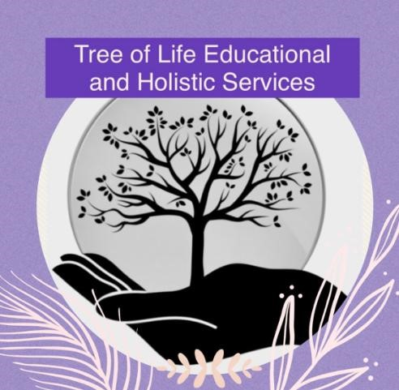

Statement on Student Support

Original - February 2024
Updated – September 2024
Reviewed Annually

This statement covers the following areas:

- Information, Advice and Guidance (IAG)
- Initial Assessment and Induction
- Unique Learner Number (ULN)
- Withdrawal

Information, Advice & Guidance
Impartial high quality information advice and guidance to meet your needs before you become a learner and whilst you are a learner at Tree of Life.

Initial Assessment
It is the aim of Tree of Life to ensure all learners receive a non-discriminatory Initial Assessment that identifies their learning needs in order that an accurate and realistic learning plan can be agreed.

To achieve this aim Tree of Life will do the following:

- Use interviews and discussion to involve learners in the Initial Assessment process.
- Identify any learning difficulties that require additional support.
- Identify any personal circumstances which may affect learning and training.
- Use a range of evidence in the Initial Assessment process.
- Identify occupational skills or preferences for learners.
- Use the information collected to place learners on the level of programme most appropriate to their needs.
- Give feedback to learners on the outcome of their Initial Assessment.
- Provide Learners with access to information and support them in using it.
- Support learners in exploring options and making decisions.

Unique Learner Number
A Unique Learner Number is a 10-digit number which is unique to the learner and is used in England, Northern Ireland and Wales.

The use of the Unique Learner Number (ULN) in further education is now a mandatory requirement for publicly-funded Further Education (FE). A learner can choose not to have a ULN, but no data can be added to a Personal Learning Record without one.

As an approved Centre, we will obtain and validate the ULN for the learner and to supply this information to Open Awards as part of the learner registration process. If a learner supplies a ULN the centre will be required to validate this before they submit registrations to Open Awards.

Further information on ULNs can be found at: www.learningrecordsservice.org.uk/products/uln/

Process to Protect Interest of Learners in the Event of Withdrawal
Tree of Life will take all reasonable steps to protect the interests of Learners in the case of such a withdrawal. This will apply whether the withdrawal is voluntary or not from our perspective.

Tree of Life will cooperate and adhere to the process specified by the awarding organisation for the withdrawal of the Centre from the delivery of a qualification or all qualifications.

NB; Where a student withdraws from a programme prior to completing all the required outcomes, a process will be in place to recognise the achievements to that date and will result in the awarding of certification for all fully completed units (Certificate of Unit Credit).

