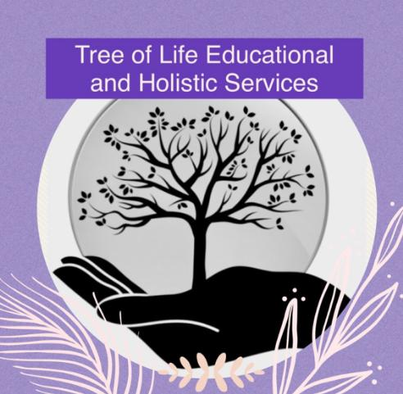

**Assessment Policy**

**Original: January 2023**

**Updated: September 2024**

**Reviewed Annually**

At Tree of Life Educational and Holistic Services CIC, assessment is not a singular activity, it is both about the measurement of performance at a given point in time and an ongoing process of gaining information to promote future learning.

We appreciate the differing needs of all students, and we will work with each individual to personalise the assessment process within our curriculum, there may need to be alternative approaches in place to enhance outcomes.

Assessment provides opportunities for students to reach their full potential in lessons and for teachers to ensure that lessons are planned to meet individuals needs, as well as providing information about student attainment in lessons.

Students will be informed of their progress in lessons through verbal feedback and marking as well as further guidance form staff, this promotes a coherent approach throughout.

Assessment also provides information on personal, social and emotional progress.

The purposes of the assessment are:

* To identify students’ progress and needs to evaluate the success of teaching to, in turn, motivate students
* To provide information for students, parents, teaching staff, statutory bodies and other educational settings
* To provide regular information to staff to ensure support is put in to place
* To ensure progression through the curriculum which in turn leads to success
* To embed ambition through target setting

At Tree of Life Educational and Holistic Services CIC we will be using an internal tracking system using RAG (Red, Amber, Green) tracking.

Assessment strategies will take many forms, these can include teacher observations linked with feedback and students knowing the next steps, effective verbal feedback from staff and more formal assessments of written or recorded work.

Learning in lessons is regularly marked and teachers provide both written and verbal feedback. This narrative allows students to gain confidence in their abilities and can improve their work in order to develop towards next steps in learning. Building a dialogue between teaching staff and students develops a strong reflection of skills and a desire to make improvements as well as creating resilience and encouraging independence.

At the end of learning blocks, an appropriate summative assessment will be given that involves more of a diagnostic judgement of what the student is capable of at that point.

Personal, social and emotional progress will be updated regularly through Boxall and Solar.

Progress across the curriculum is recorded through an internal academic tracker as well as identifying achievement and progress on a more informal basis.

Teaching staff can review progress in a number of ways:

* Internal tracker
* Teacher planning
* Students exercise books
* Internal and external accreditation (KS4)
* EHCP targets
* Boxall
* Solar
* Annual Review/PEP meetings
* Parents meetings
* Reports to parents/carers

At Key stage 4, students follow accredited courses which are determined by their attainment at that age. This path is to follow Entry Level, Functional Skills, GCSE’s, Open Awards and ASDAN.

Annual reports to parents will be towards the end of the academic year for those students who have attended for at least a term. Teachers are responsible for writing and collating these reports. Reports are processed on what has been undertaken by the students and what progress has been made over the year. These reports will also include personal ,social and emotional progress as well as key strengths not linked to academic targets.