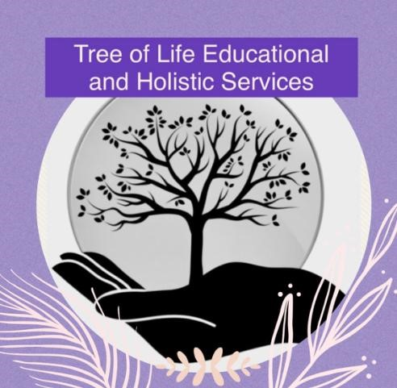

Transporting Children Policy

Original: January 2023
Updated: September 2024
Reviewed Annually

The safety of your child is paramount and Tree of Life Educational and Holistic Services CIC have therefore put together the following procedures regarding the transportation of children in our cars, minibus and on public transport.

Vehicle Safety
- We have a full, clean driving license, which is available for you to see on request.
- We will ensure our vehicles are in a roadworthy condition, with a valid MOT certificate and road tax.
- We will ensure we have adequate motor insurance, which covers business use and that the certificate is available for you to see upon request.
- Where possible, we will avoid taking your child to a petrol station by filling up our vehicles prior. In the event of unexpectedly needing petrol, we will use a garage that has pay at the pump services.
- We will ensure that all car seats are correctly fitted, following the manufacturer's instructions, that they are age and stage appropriate for the children using them, and that children are correctly strapped into them at all times.
- We will ensure that the maximum number of passengers for the vehicles are never exceeded.
- We will ensure that the child safety locks are in use in our vehicles, along with window locks.
- We will never leave a child unattended in the vehicle.

General
- We will teach children about the dangers of cars and roads in an age-appropriate way
- We will advise you in advance if we are making any trips in the car, minibus or on public transport
- We will always carry a mobile phone in case of an emergency but will not answer it while driving
- We will always carry identification and emergency contact details for children in case of an emergency
- We will always carry a first aid kit in the car in case of an accident or emergency
- We will discuss with the children how to stay safe and what is appropriate behaviour before leaving the setting

Public Transport
- We will supervise children carefully at all times on public transport to ensure they are behaving well and being respectful to others around us
- We will ensure that there is space for all children to sit down with us or close to us. We will wait for the next bus/tram/train if this is not possible
- We will not allow children to sit next to strangers
- Where possible, we will sit downstairs on buses. If the children can safely go upstairs, then we will ask the driver to wait until we are all seated before moving
- If there is a gap or large step to get on or off a bus/tram/train, then we will help children to climb it safely

If your child suffers from travel sickness, please let Tree of Life know immediately and we can discuss the practicalities in more detail.

Page 1 of 2

