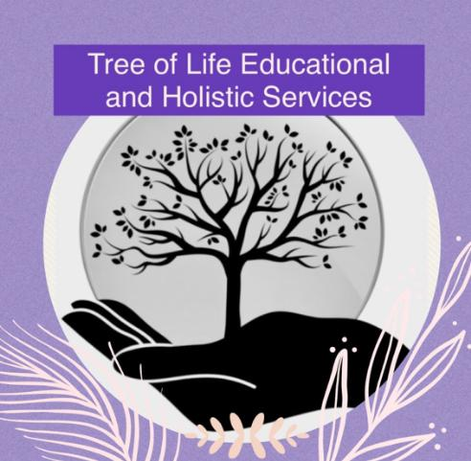

**E-Learning and Computing Policy**

**Original: August 2022**

**Updated: September 2024**

**Reviewed Annually**

The internet and information technologies are powerful tools which open up new opportunities for everyone. Electronic communication enables staff and pupils to learn from each other by stimulating discussion, promoting creativity and stimulating awareness of context to promote effective learning. The requirements to ensure that children and young people are able to use the internet and related communication technologies appropriately and safely is addressed as part of the wider duty of care to which all who work in the provision are bound. Safe internet practices must be embedded into the culture of our provision. All staff have a duty to ensure that pupils using ICT, in any context, are reminded about appropriate behaviour on a regular basis. All staff will undergo annual training in E-safety. ICT can offer many positive social and educational benefits to young people but unfortunately there are a number of dangers. Pupils are very vulnerable and can expose themselves to danger with or without knowing when using the internet or other technologies and could even find themselves involved in illegal activities. They may also initiate some issues outside of the provision that may have influence or be brought into the provision and so we must consider use of pupil’s own equipment as well e.g. bullying via chat or text messages.

It is the duty of Tree of Life Educational and Holistic Services to ensure that filtering and monitoring legislation is adhered to and that the designated Safeguard Lead oversees reports, concerns and checks to filtering and monitoring systems. The DSL and directors will work with the IT provider to procure systems, identify risks and carry out reviews and checks. This should be reviewed annually and part of the filtering and monitoring review process, as stated in “Keeping Children Safe in Education 2023”.

At Tree of Life Educational and Holistic Services, we take responsibility to educate our pupils by teaching them the appropriate behaviours and thinking skills to remain both safe and legal when using the internet and related technologies. It is vital that the provision provides a safe learning environment for all pupils and that everyone is aware of the issues and how they impact upon our environment and the pupils. Education is essential in assisting children to better protect themselves and recognise when they are in danger. All staff must be aware of their responsibilities with regard to internet safety for pupils in their care.

Filtering and Monitoring needs to take into consideration;

* the risk profile of your pupils, including their age range, pupils with special educational needs and disability (SEND), pupils with English as an additional language (EAL)
* what your filtering system currently blocks or allows and why
* any outside safeguarding influences, such as county lines
* any relevant safeguarding reports
* the digital resilience of your pupils
* teaching requirements, for example, your RHSE and PSHE curriculum
* the specific use of your chosen technologies, including Bring Your Own Device (BYOD)
* what related safeguarding or technology policies you have in place
* what checks are currently taking place and how resulting actions are handled

The filtering and monitoring review will inform;

* related safeguarding or technology policies and procedures
* roles and responsibilities
* training of staff
* curriculum and learning opportunities
* how often and what is checked
* monitoring strategies

Systems that Tree of Life Educational and Holistic Services has in place in order to safeguard pupils and staff are:

* A firewall and virus protection
* Filtering and monitoring by staff to minimise access to inappropriate content
* Observant staff including good communication with parents through communication books and teams of staff who oversee pupils on a daily basis
* All pupils have regular PHSE and PPR sessions where online safety and IT related issues may be covered as appropriate
* The provision’s equipment will only be used during the pupils sessions and not taken home by pupils
* No personal iPad, iPod, laptops, mobile phones etc to be used at Tree of Life Educational and Holistic Services by pupils
* Pupils may only access YouTube under staff supervision and material viewed must be appropriate for their age and the session underhand
* Pupils may NOT download games or programmes onto laptops or iPads. Should there be a need to add a programme to any laptop for use in sessions, permission and approval must be sought from a member of the management team
* All laptops and iPads have been audited to allow only authorised programmes and apps to be accessed and will be subject to regular scrutiny by staff to ensure no unauthorised programmes or apps have been installed
* Only authorised and age appropriate games may be used by pupils
* Pupils are only allowed to play on games that are “single player/internal mode”, i.e. they will not connect or converse with the internet connection to facilitate access to players external to the provision. This includes the Xbox.

**Potential Risks**

Copyright infringement – copyright law applies on the internet but is often ignored and pupils can download and swap music files, cut and paste work from other pupils’ files. Obsessive use of internet and ICT – factors such as spending a significant amount of time online, deterioration of the quality of work, diminished sleep time or negative impacts on family relationships may all be indicators that the internet is taking too high a priority in pupil’s lives.

Exposure to inappropriate materials – e.g. pornographic, hateful or violent in nature, encouraging activities that are dangerous or illegal or are just age-inappropriate or biased. Extreme political or racist or sexist views can be separated to give a distorted view of the world.

Inappropriate or illegal behaviour – groups or cliques can form online, and activities that begin as harmless fun can escalate into something much more serious. Online bullying is perceived as an anonymous method of tormenting victims, at any time day or night. A young person may receive email, chat or text messages which may not put them in physical danger but can embarrass, upset, frighten or depress them. This can lead to damage to self-esteem and may pose a threat to their psychological well being. Viewing of indecent images via websites is something to be alarmed about. Any concern relating to criminally racist content should be reported to the police.

Physical danger and sexual abuse – this is the most worrying and extreme risk associated with the use of the internet and other technologies. A criminal minority use the internet and related services e.g. chat rooms to make contact with young people to persuade them into sexual activity. The techniques used are online enticement, grooming or child procurement. A young person can provide information online that can personally identify them or others or they can arrange to meet people online thereby posing a threat to themselves or family or friends.

Inappropriate or illegal behaviour by staff – unfortunately it has occurred, very infrequently and in some settings, where staff have been involved in inappropriate or illegal behaviour relating to ICT use. This could include viewing or circulating inappropriate material via email, or more serious activities such as viewing, possessing, making or distributing indecent/pornographic images. Therefore we have a responsibility to educate staff as to acceptable behaviours online and to monitor networks for evidence of inappropriate activity. (All staff are issued with the provision’s code of conduct and expected to comply). If inappropriate behaviour is found, this will result in disciplinary action by the provision. If illegal activities are found, the provision has a duty to consult with police at the earliest opportunity and any evidence must be preserved.