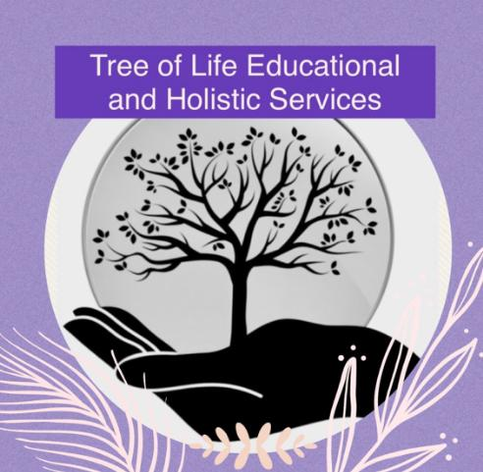

**Curriculum Policy**

**Original: January 2023**

**Updated: September 2024**

**Reviewed Annually**

Tree of Life Educational and Holistic Services CIC seeks to promote a curriculum that maximizes every individuals’ potential and to embrace unique qualities in order to unlock hidden qualities and the way they view the world around them in a nurturing and holistic manner to begin a life sustaining, successful, academic and independent future that is right for each individual. We aim to build an accessible curriculum which enables them to achieve as highly as possible and to experience success both academically and personally. We aim to underpin the teaching of basic skills, knowledge and values and constantly provide opportunities for enrichment. Our ambition is to ensure that there are vast experiences and opportunities to create new skills, knowledge and independence. All children have the right to a broad, balanced and relevant curriculum which provides progression alongside taking individual differences into account. At Tree of Life Educational and Holistic Services CIC students will have access to a personalised, bespoke curriculum based on the National Curriculum as well as being relevant to the individuals’ needs. Tree of Life Educational and Holistic Services CIC focuses on the core difficulties which lie at the heart of the students’ struggles. Our curriculum involves academic learning but our initial priority is to work on any difficulties each individual may have that could be a barrier to their learning journey. Many of our students’ learning journey are project and activity based on an area of study which links to the National Curriculum but also meets the learning needs of the individual. This specialist curriculum is differentiated to the students age, level of ability, interests and own aspirations, as well as incorporating therapeutic support throughout the curriculum to focus on developing resilience and preparing students for their next journey. Our specialist curriculum is based on person centred planning, incorporating prior experiences and knowledge as well as fostering students social, moral, spiritual and cultural development.

At Tree of Life Educational and Holistic Services CIC our intention is to:

* Improve self regulation as well as managing emotions and behavioural challenges
* Improve resilience and coping with change
* Decrease anxiety whilst increasing mental health and wellbeing
* Improve, develop and maintain meaningful and healthy relationships
* Increase independence and life long skills
* Increase quality of life with a reduction of stress for students and their families

Children with social emotional and mental health difficulties (SEMH) and additional needs will thrive with our bespoke approach to teaching and learning. Our assessments will be used to create a personalised, creative curriculum that will be tailored to meet their needs and interests. We aim to create a safe learning environment for children with:

* Autistic Spectrum Conditions
* Social, Emotional and Mental Health needs
* Moderate Learning Difficulties
* Communication and Interaction difficulties
* Cognition and Learning difficulties

In planning a holistic curriculum, we will assist children’s knowledge, skills and qualifications which will help them develop intellectually, emotionally, socially, morally, physically and personally whilst catering for the needs of each individual along their learning journey. Children will become independent, responsible and confident members of the community. At Tree of Life Educational and Holistic Services CIC we endeavour to create an exciting and stimulating learning environment where children feel safe, valued and able to learn, whilst tailoring this to each individuals needs. All students will experience a sense of personal achievement through encouraging them to fulfil their potential relevant to their abilities, skills and personal interests. We will ensure that each student’s journey enables them progress with confidence to the next stage of their learning journey in preparation for adult life.

Students will be given opportunities to learn through, problem solving in a variety of situations, read, write, speak and listen, develop an enquiring mind, use and develop technological skills, have some knowledge of beliefs of the major world religions, develop agility, co-ordination and confidence in movement as well as learn re-regulation and self-regulation strategies. All of the above will incorporate independent thinking and life long skills.

Our curriculum works through a personalised curriculum to support students individuals needs, focusing on the social and emotional as well as academic development. Students are taught in small groups, depending on the activity and the student group as well as considering students needs according to their EHCP.

**EYFS**

A thematic approach to learning through play, ensuring early learning goals 2021 are achievable and that children work towards the EYFS framework.

•English

•Maths

•Phonics

•Topic

•PSHE

•Mental Health

•Music and Movement

•Creative

•PE and outdoor learning activities

**KS1/2**

A thematic approach to learning through topic based activities, ensures that the following National Curriculum subjects are experienced at some point during the academic year

* English
* Maths
* Phonics
* Science
* IT
* Arts and Crafts
* PSHE
* Life Skills
* Mental Health
* Humanities
* Movement and music
* Humanities
* PE and outdoor learning activities

**KS3/4**

* English
* Maths
* Science
* ICT
* PSHE
* Mental Health
* Life Skills
* Art, craft, design and cookery
* Humanities
* PE and outdoor learning acitivites

In Key Stage 4 students have opportunities to develop personal interests, due to their development needs and in most cases time out of school during previous settings, most students have not acquired the academic age expectations of their chronological age when they come to Tree of Life Educational and Holistic Services CIC, for this reason our emphasis is on progression measured from students’ starting point at Tree of Life.

Students are carefully assessed so that we can be sure they can meet appropriate challenges. We also give students opportunities to gain qualifications and accreditations, both exam based and non-exam based. Staff make use of ASDAN award programmes with older pupils in many areas to gain certification, this enables all pupils to gain accreditation that is nationally recognised and appropriate to their needs and interests as well as improving self esteem and confidence. In Key Stage 4 we promote work experience and these are set up in areas identified by the individual.

Some students are academically able, sometimes their difficulties managing their anxieties mean the pressure of taking exams is counter-productive, as it could be detrimental to their emotional wellbeing, however, for those students who are deemed able to cope with exams, we offer Functional Skills in Maths and English as well as Entry level awards. GCSE’s will be offered on an individual basis on the abilities and academia of the student.

Education should be fun and we constantly seek enriching learning opportunities by giving students a say in what they learn about as well as engaging with external cultural partners such as libraries, museums, theatres, swimming baths, authors and many others. Throughout the curriculum we encourage students to respect fundamental British Values of democracy, the rule of law, individual liberty and mutual respect and tolerance of those with different faiths and beliefs.