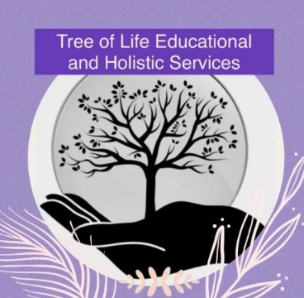

**Risk Assessment Policy**

**Original: September 2022**

**Updated: September 2024**

**Reviewed Annually**

**Introduction**

We aim to provide a safe, secure and comfortable learning and working environment for pupils, staff and visitors. We always strive to provide pupils with a rich and challenging curriculum where calculated risks are taken, in order for pupils to achieve their full potential. We recognise that risks are present in all aspects of our work, and have systems in place to ensure that risks are minimised.

**Fundamental principles**

All staff are made aware of this procedure through induction and staff training. This policy, as with all Tree of Life’s policies, can be found in the policy file.

Pupils: All pupils at Tree of Life require varying levels of supervision to ensure their safety and welfare. An individual risk assessment is in place for each pupil and all staff working with our young people at premises will be aware of the information. It is the responsibility of Tree of Life staff to highlight any additional risks or changes as required through daily briefings or staff meetings.

Activities: Generic activity risk assessments together with individual pupils risk assessments and specific area risk assessments are in place for day to day activities in the provision. Where an additional, non-regular activity is planned, staff should complete the irregular activity risk assessment in advance, and after discussion with, and approval by management of planned activity. Offsite activities can be a regular occurrence and in all cases a workplace risk assessment will be obtained from the external provider and in addition, staff will complete the provision risk assessment for off-site visits. All off site visits will be requested of, and approved by management in advance.

**Monitoring and evaluating**

At staff meetings and daily briefings, staff should raise any risk and health and safety matters that require clarification or follow up action/work or repair. These will be further reviewed by management and control measures suggested, if not dealt with at the time.

Pupil risk assessment information will be reviewed at least on an annual basis by all staff at a staff meeting.

By following the procedures above, we will ensure that risks are minimised for everyone at Tree of Life.