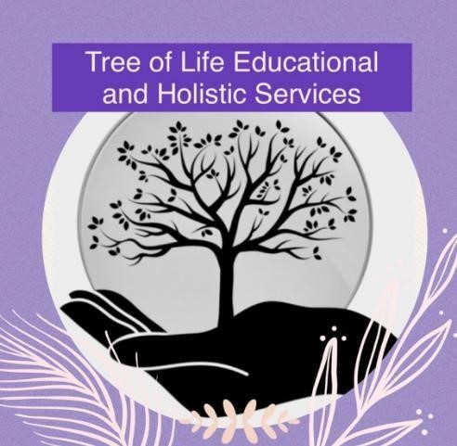

**Malpractice and Maladministration Policy**

**Original - February 2024**

**Updated - September 2024**

**Reviewed Annually**

# **Definition**

“Malpractice” means any act, default or practice which is in breach of the regulations which:

•Compromises, attempts to compromise, or may compromise, the process of assessment/examinations, the integrity of any qualification or the validity of an examination result or certificate, including maladministration.

•Damages the authority, reputation or credibility of the awarding organisation or centre or any officer, employee or agent of any awarding organisation or centre.

•Involves a failure by a centre to investigate allegations of suspected malpractice in accordance with the requirements of the Awarding Organisation also constitutes malpractice.

“Maladministration” specifically means any activity, neglect, default or other practice that results in a centre not complying with the specified requirements for delivery of the qualifications as set out in the guidance.

# **Policy**

Tree of Life Educational and Holistic Services CIC is committed to ensuring access to fair assessment for all learners and to protecting the integrity of the award of credit and qualifications. Tree of Life has a responsibility to ensure that malpractice, non compliance and maladministration is addressed effectively and to publish procedures to stakeholders for dealing with malpractice on the part of learners, centre staff and any others involved in providing the qualification.

Tree of Life Educational and Holistic Services CIC requires any member of personnel working within the centre, any learner or any relevant person to report immediately to the Head of Education (Laura Frain) any suspected case of malpractice committed in direct relation to the Centre’s recognised centre requirements and/or any qualification-specific criteria.

The Head of Education has responsibility for reporting all suspicions or actual incidents of malpractice to the Awarding Organisation. Reports should be made using the Awarding Organisations specific forms.

The Head of Education will supervise personally all investigations resulting from an allegation of malpractice, however if it is necessary to delegate an investigation to a member of staff, the Head of Education will ensure that the member of staff selected is independent, and not connected to the department involved in the suspected malpractice.

Tree of Life Educational and Holistic Services CIC will respond speedily and openly to all requests for an investigation into an alleged malpractice, as this is in the best interests of centre staff, candidates and any others involved.

Tree of Life Educational and Holistic Services CIC will cooperate and ensure their staff cooperate fully with an enquiry into an allegation of malpractice/maladministration, whether the centre is directly involved in the case or not.

Tree of Life Educational and Holistic Services CIC will inform staff members and learners of their individual rights and pass on to the individuals concerned any warning or notification of penalties.

Tree of Life Educational and Holistic Services CIC will ensure compliance with any requests made by the Awarding Organisation as a result of malpractice.