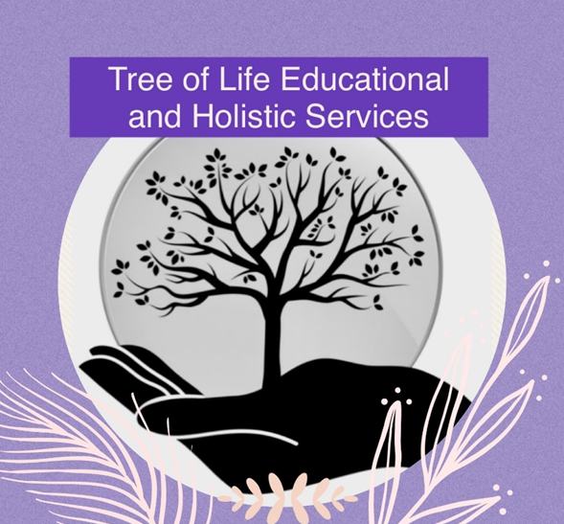

**Illness Policy**

**Original – August 2022**

**Updated – September 2024**

**Reviewed Annually**

Our policy for illness and communicable diseases follows the advice as recommended by the December 2017 publication from Public Health England – ‘Health protection in schools and other childcare facilities’ which should be read in conjunction with this policy.

At Tree of Life we aim to prevent the spread of infections by encouraging and ensuring:

• High standards of personal hygiene and practice, particularly handwashing

• We maintain a clean environment

• Consistent and clear communication with parents and carers.

The provision will inform parents as soon as possible if any child has contracted or been in contact with anyone who has a contagious disease. This will be done verbally and in writing (email). Where possible, the provision will inform parents verbally of any suspected health issues or illness specific to their child where medical advice should be sought. An email will always be sent. We also expect parents to verbally inform our staff if their child/any family member has been exposed to any contagious disease or infection. The provision will request parents to keep their child at home within the following guidelines. This is for the safety and promotion of good health within the provision.

|  |  |
| --- | --- |
|  |  |
| **Chickenpox** | Five days from onset of rash |
| **Athlete’s foot** | None (Athlete’s foot is not a serious condition. Treatment is recommended.) |
| **Cold sores**(herpes simplex) | None (Avoid kissing and contact with the sores. Cold sores are generally mild and heal without treatment.) |
| **Conjunctivitis** | None (If an outbreak/cluster occurs, consult your local HPT) |
| **Diarrhoea and vomiting** | Whilst symptomatic and 24 hours after the last symptoms. |
| **Diptheria** | Exclusion is essential. Always consult your local HPT |
| **Flu (influenza)** | Until recovered |
| **Glandular fever** | none |
| **Head lice** | None (Treatment recommended only when live lice are seen.) |
| **Hand, foot and mouth** | none (Contact your local HPT if a large number of children are affected. Exclusion may be considered in some circumstances.) |
| **Impetigo** | Until lesions are crusted / healed, or 48 hours after starting antibiotic treatment (Antibiotic treatment speeds healing and reduces the infectious period.) |
| **Measles** | Four days from onset of rash and recovered. (Preventable by vaccination (2 doses of MMR). Promote MMR for all pupils and staff. Pregnant staff contacts should seek prompt advice from their GP or midwife.) |
| **Hepatitis A** | Exclude until seven days after onset of jaundice (or 7 days after symptom onset if no jaundice).( If an outbreak of hepatitis A, your local HPT will advise on control measures.) |
| **Hepatitis B*, C*, HIV** | None (Hepatitis B and C and HIV are blood borne viruses that are not infectious through casual contact. Contact your local HPT for more advice.) |
| **Meningococcal meningitis* / scepticaemia** | Until recovered (Meningitis ACWY and B are preventable by vaccination (see national schedule @ www.nhs.uk). Your local HPT will advise on any action needed.) |
| **Meningitis* due to other bacteria** | Until recovered. ( Hib and pneumococcal meningitis are preventable by vaccination (see national schedule @ www.nhs.uk) Your local HPT will advise on any action needed.) |
| **Meningitis viral** | None. (Milder illness than bacterial meningitis. Siblings and other) |
| **Ringworm** | Not usually required. (Treatment is needed.) |
| **Threadworms** | None (Treatment recommended for child and household.  close contacts of a case need not be excluded.) |
| **MRSA** | None (Good hygiene, in particular handwashing and environmental cleaning, are important to minimise spread. Contact your local HPT for more information.) |
| **Mumps** | Five days after onset of swelling (Preventable by vaccination with 2 doses of MMR (see national schedule @ www.nhs.uk). Promote MMR for all pupils and staff.) |
| **Rubella** **(German measles)** | Four days from onset of rash (Preventable by vaccination with 2 doses of MMR (see national schedule @ www.nhs.uk). Promote MMR for all pupils and staff. Pregnant staff contacts should seek prompt advice from their GP or midwife.) |
| **Scarlet fever** | Exclude until 24hrs of appropriate treatment completed. ( A person is infectious for 2-3 weeks if antibiotics are not administered. In the event of two or more suspected cases, please contact local health protection.) |
| **Scabies** | Can return after first treatment (Household and close contacts require treatment at the same time.) |
| **Slapped cheek / Fifth disease / Pavro virus B19** | None (once rash has developed)  (Pregnant contacts should consult with their GP or midwife.) |
| **Tonsillitis** | None (There are many causes, but most cases are due to viruses and do not need an antibiotic treatment.) |
| **Tuberculosis (TB)** | Always consult your local HPT BEFORE disseminating  information staff/parents/carers.(Only pulmonary (lung) TB is infectious to others. Needs close, prolonged contact to spread.) |
| **Warts and verrucae** | None (Verrucae should be covered in swimming pools, gyms and changing rooms.) |
| **Whooping Cough** **(pertussis)\*** | Two days from antibiotic treatment, or 21 days from onset of symptoms if no antibiotics  (Preventable by vaccination. After treatment, infection coughing may continue for many weeks. Your local HPT will organise any contact tracing.) |

It is a statutory requirement that doctors report a notifiable disease to the proper officer of the local authority (usually a consultant in communicable disease control). Health Protection Agency (2010) Guidance on Infection Control in Schools and other Child Care Settings. HPA: London.

**Vulnerable children**

Some medical conditions make children vulnerable to infections that would rarely be serious in most children. These include those being treated for leukaemia or other cancers, on high doses of steroids and with conditions that seriously reduce immunity. Schools, nurseries and childminders will normally have been made aware of such children. These children are particularly vulnerable to chickenpox, measles or parvovirus B19 and, if exposed to either of these, the parent/carer should be informed promptly and further medical advice sought.

**Female staff – pregnancy**

If a pregnant woman develops a rash or is in direct contact with someone with a potentially infectious rash, this should be investigated according to PHE guidelines by a doctor. The greatest risk to pregnant women from such infections comes from their own child/children, rather than the workplace. Some specific risks are:

• Chickenpox can affect the pregnancy if a woman has not already had the infection. Shingles is caused by the same virus as chickenpox, so anyone who has not had chickenpox is potentially vulnerable to the infection if they have close contact with a case of shingles

• German measles (rubella). If a pregnant woman comes into contact with German measles she should inform her GP and antenatal carer immediately to ensure investigation. The infection may affect the developing baby if the woman is not immune and is exposed in early pregnancy

• Slapped cheek disease (parvovirus B19) can occasionally affect an unborn child

• Measles during pregnancy can result in early delivery or even loss of the baby.

In the first instance, pregnant staff should contact their midwife/doctor asap for guidance and advice and inform the Head of Learning of the outcome/advice.

This advice also applies to pregnant students.

**CORONAVIRUS (Covid 19)**

The coronavirus pandemic has raged since late 2019 when the first cases were diagnosed in Wuhan, China. The first two cases of Covid-19 in the UK were diagnosed on January 29, 2020. The first Covid-19 death wasn’t until March 5, and by that point 100 cases had been confirmed. By the time the lockdown was enforced on March 23, official figures showed that the death toll was 335 and that 6,650 people were confirmed to have had the virus so far at the time. Schools have been guided by Government guidance since a pandemic was declared in 2020 and the provision may be closed to protect everyone. Tree of Life has its own risk assessment in dealing with Covid 19 and this will be implemented as appropriate.

Note:

PHE = Public Health England, an agency of the Department of Health

HTP = Health Protection Teams which provide specialist public health advice and operational support to NHS, local authorities and other agencies.