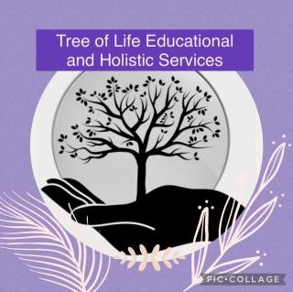

**Marking Policy**

**Original - September 2022**

**Updated – September 2024**

**Reviewed Annually**

At Tree of Life Educational and Holistic Services CIC, marking is an integral part of assessment. Our marking and Feedback Policy has been discussed and agreed by all members of staff. All pupils, parents and proprietors will be made aware of this policy, which offers guidance on the purpose, types and frequency of marking.

**Our Aims**

We strive to:

* Mark children’s work positively to reflect the nurturing ethos of our provision
* Enhance self -esteem and confidence of our pupils
* Mark written work regularly and consistently highlighting strengths and areas for development using child friendly approaches
* Provide a system for marking which is consistent across all areas in our provision
* Ensure our marking informs all teachers in their planning of future activities and enhances pupil’s learning by offering advice on areas to be improved

• Enable children to clearly recognise their difficulties and mistakes.

* Provide children with clearly identifiable “next steps” they need to take in their learning

**Why do we mark children’s work?**

* To help staff to monitor pupil’s progress and diagnose what has not been understood. This assists future planning and learning
* To provide helpful feedback to children so that:
* Their needs are identified and we can discuss the areas of their work they find difficult
* They are clearly aware of what they need to do next to improve
* Their achievements are recognised and their confidence is nurtured
* To ensure pupils are aware that their work is valued
* To allow staff to ensure that set tasks have been carried out
* To show progress has clearly been made

**Marking and feedback should;**

•Be manageable for staff and accessible to the children

•All sessions have clearly identified learning objectives, which are shared with pupils at the start of the session

•Marking and feedback relates to the learning objective

•Involve the staff working with the children

•Give recognition and praise for achievement

•Respond to individual learning needs taking opportunities to mark in the moment where appropriate.

•Allow specific time for children to read, reflect and/or discuss marking where appropriate

•Marking information aims to inform future planning

•Use the agreed session feedback guide (as below)

Assessment evidence can be found through a range of sources, which may include: • teacher analyses of the work pupils have done.

* + interviews and discussions with pupils
  + observations
  + listening
  + pupils' self-assessment of work
  + assessment suited to needs

In addition to staff giving feedback during and at the end of sessions, pupils are also encouraged to discuss their thoughts and feelings each session. This in turn will enable staff to match their own assessment with that of the pupils’ and take appropriate action/ put in strategies to deal with any difference in opinion in order that learning outcomes can be successful and progress is made.

**Work Books and Worksheets**

Each piece of work should have:

Date

LO – Learning Objective

Next to the work teachers should mark where appropriate

Supported (S)

Guided (G)

Independent (I)

Verbal Feedback (V)

If there is a mistake or a misconception – mark if you have discussed it together in one piece of work all four of the above symbols could be used.

Work should also have a comment from staff – praise and/or next steps, however due to the complex needs of the pupils, they may not respond positively to comments (positive or negative) or corrections on their work, this will be completed if deemed appropriate.

Marking will be completed in the following colours;

Pink for staff marking

Green for self marking

Purple for peer marking