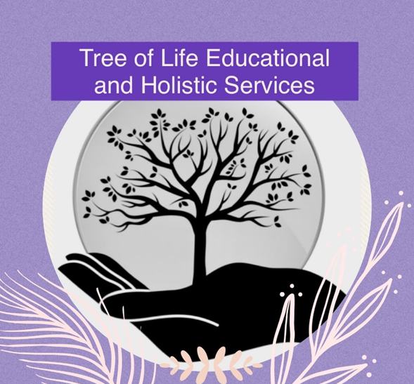

**Safer Recruitment Policy**

**Original: August 2022**

**Updated: September 2024**

**Reviewed Annually**

The safe recruitment of staff and volunteers in schools and educational provisions is the first step to safeguarding and promoting the welfare of the children in education. Tree of Life is committed to safeguarding and promoting the welfare of children and young people and expects all staff and volunteers to share this commitment. It is recognised that this can only be achieved through sound procedures, good inter-agency cooperation and the recruitment and retention of competent, motivated employees who are suited to, and fulfilled in the roles they undertake.

This provision recognises the value of, and seeks to achieve a diverse workforce which includes people from different backgrounds with different skills and abilities. The provision is committed to ensuring that the recruitment and selection of all who work within the school is conducted in a manner that is systematic, efficient, effective and promotes equality of opportunity. The provision will uphold its obligations under law and national collective agreements to not discriminate against applicants for employment on the grounds of age, sex, sexual orientation, marital status, disability, race, colour, nationality, ethnic origin, religion or creed.

**Aims and Objectives**

The aims of the Safer Recruitment policy are to help deter, reject or identify people who might abuse pupils or are otherwise unsuited to working with them by having appropriate procedures for appointing staff and volunteers.

The aims of Tree of Life recruitment policy are as follows:

* to ensure that specialist staff are recruited on the basis of their merits, abilities and suitability for the position
* to ensure that all job applicants are considered equally and consistently
* to ensure that no job applicant is treated unfairly on any grounds including race, colour, nationality, ethnic or national origin, religion or religious belief, sex or sexual orientation, marital or civil partner status, disability or age
* to ensure compliance with all relevant legislation, recommendations and guidance including the statutory guidance published by the Department for Education (DfE), Keeping Children Safe in Education - September 2019 (KCSIE), the Prevent Duty Guidance for England and Wales 2016 (the Prevent Duty Guidance) and any guidance or code of practice published by the Disclosure and Barring Service (DBS)
* to ensure that the provision meets its commitment to safeguarding and promoting the welfare of children and young people by carrying out all necessary pre-employment checks
* to ensure all volunteers are suitably vetted

Employees involved in the recruitment and selection of staff are responsible for familiarising themselves with and complying with the provisions of this policy.

The Provision has a principle of open competition in its approach to recruitment and will seek to recruit the best applicant for the job. The recruitment and selection process should ensure the identification of the person best suited to the job at the provision based on the applicant’s abilities, qualifications, experience and merit as measured against the job description and person specification.

The recruitment and selection of staff will be conducted in a professional, timely and responsive manner and in compliance with current employment legislation, and relevant safeguarding legislation and statutory guidance (including KCSIE 2019 and Prevent Duty Guidance).

If a member of staff involved in the recruitment process has a close personal or familial relationship with an applicant they must declare it as soon as they are aware of the individual’s application and avoid any involvement in the recruitment and selection decision-making process.

The provision aims to operate this procedure consistently and thoroughly while obtaining, collating, analysing and evaluating information from and about applicants applying for job vacancies at Tree of Life.

**Recruitment Procedure**

Advertising:

All vacant posts will be advertised to ensure equality of opportunity and encourage as wide a field of candidates as possible. This will normally mean placing an advertisement externally including on the website. However, where there is a reasonable expectation that there are sufficient, suitably qualified internal candidates, or staff are at risk of redundancy, vacancies may be advertised internally before an external advertisement is placed. Any internal recruitment process will follow the procedures set out in this policy.

All advertisements for posts will include the following statements:

“Tree of Life Educational and Holistic Services CIC is committed to safeguarding and promoting the welfare of children and young people and requires all staff and volunteers to share and demonstrate this commitment”

“The successful candidate will be subject to pre-employment checks including an enhanced DBS check, a Disqualification By Association check, and satisfactory references.”

Applications:

All vacancies should be applied for by a letter of application, expressing interest in the post, together with a CV and details of two referees.

Short Listing and Reference Requests:

The selection panel will include at least one director and one person who has undergone the “Safer Recruitment” training.

The selection panel will agree the applicants to be invited to interview.

Reference requests will ask the referee to confirm, in writing:

- The referee’s relationship to the candidate.

- The candidate’s performance history and conduct.

-Whether the candidate has been subject to disciplinary action relating to the safety and welfare of children,

- Whether the referee has any reservations as to the candidate’s suitability to work with children and young people (if so, Tree of Life will ask for specific details of the concerns and the reasons why the referee believes the candidate may be unsuitable to work with children).

- The candidate’s suitability for the post with explicit reference to the job

description and person specification.

References must be in writing and be specific to the job for which the candidate has applied. The selection panel will not accept references from relatives or people writing solely in the capacity as a friend of the candidate, for any post. If a candidate declares they have lived or worked outside the UK, further checks will be made as necessary taking guidance from the Home Office on criminal records checks for overseas applicants and guidance on the employment of overseas-trained teachers. If the field of applicants is felt to be weak, or following the interview no suitable candidate is appointed, the post may be re-advertised.

Interviews

Before the interviews, the selection panel will agree on the interview format. Selection techniques will be determined by the nature and duties of the vacant post, but all vacancies will require an interview of short-listed candidates. Interviews will always be face-to-face when possible, however during the pandemic exceptions may be made where the interview can take place over Zoom. The same areas of questioning will be covered for each applicant and no questions which would discriminate directly or indirectly on protected characteristics under the Equality Act will be asked. The selection process for every post will include exploration of the candidate’s understanding of child safeguarding issues.

Candidates will always be required:

- To satisfactorily explain any gaps in employment.

Candidates invited to interview will receive:

- A letter confirming the interview and any other selection techniques

- Details of the interview day including details of the panel members

- Details of any tasks to be undertaken as part of the interview process

- The opportunity to discuss the process prior to the interview

The recruitment documentation will be retained. Under the Data Protection Act 2018 including GDPR, applicants have the right to request access to notes written about them during the recruitment process. After 12 months, all information about unsuccessful candidates will be securely destroyed.

Pre-appointment checks:

An offer of appointment to a successful candidate, including one who has lived or worked abroad, will be conditional upon satisfactory completion of pre-employment checks. When appointing new staff, we will:

- Verify a candidate’s identity by asking for two forms of identification

- Obtain a certificate for an enhanced DBS check with barred list information where the candidate will be engaging in regulated activity

- Verify the candidate’s right to work in the UK

- Make any further checks that we consider appropriate, if the candidate has lived or worked outside the UK. - Verify professional qualifications by having sight of original certificates

All checks will be:

- Documented and retained on the personnel file

- Recorded on the provision’s Single Central Record

- Followed up if they are unsatisfactory or if there are any discrepancies in the information received

Personnel file and Single Central Record:

Recruitment and selection information for the successful candidate will be retained securely and confidentially for the duration of his/her employment with the provision including:

- letter of application

- Interview notes – including explanation of any gaps in the employment history

- references – minimum of two

- 2 forms of identification

- Proof of right to work in the UK

- Proof of relevant academic qualifications

- Evidence of DBS clearance, Barred List (where applicable) and Teacher Prohibition checks

- Offer of employment letter and contract of employment

The provision will maintain a Single Central Record of employment checks in accordance with DfE guidance.

Start of Employment and Induction:

The pre-employment checks listed above must be completed before the employee starts work. Exceptions will never be made. All new employees will be provided with an induction programme which will cover all relevant matters of provision’s policies including safeguarding and promoting the welfare of children, child protection procedures, Health & Safety, Code of Conduct and expectations of the school. New employees will receive a mentor on their first day who will be available for informal discussions, supervisions through their probationary period and arranging training needed within their first 6 months. All new employees will be subject to a 6 month probationary period. At the end of this period, an informal meeting will be held to discuss moving forward.

Supply staff:

The provision has a non-supply policy, this means that if staff sickness is unable to be covered with staff who already work for Tree of life, then alternative arrangements will be made for pupils.

Volunteers:

All prospective volunteers will be required to complete an application form.

References will be sought and once these have been received a DBS may be applied for. All completed application forms and references will be kept on file and details held on the Single Central Record. Please see the volunteer policy for more details.

Documentation required in Personnel files:

1. Signed application form/ letter of application

2. Two forms of identification

3. Right to live and work in the UK

4. Qualification certificates

5. Teachers only – QTS/QTLS Certificate

6. Two written references

8. DBS details

9. Recruitment notes

10. Contract