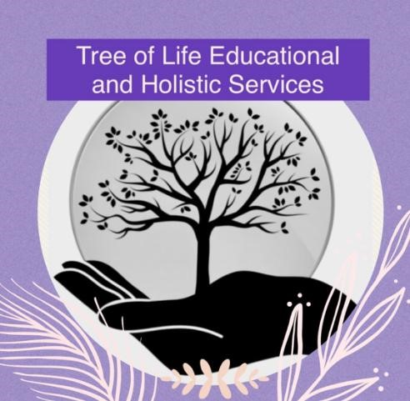

Distribution of Certificates Policy

Original - February 2024
Updated - September 2024
Reviewed Annually

Open Awards will issue certificates for learners who have successfully completed unit(s), within 20 working days of receipt of verified results.

All certificates will be forwarded to Tree of Life, via recorded delivery, for the attention of the Business Manager, Sarah Cryer.

Tree of Life will notify Open Awards within 5 working days of any identified problems with the certificates received. Once we have checked that all certificates are present and correct, we will confirm receipt within 10 working days via the Secure Portal.

Tree of Life will issue learner certificates within 7 working days of receipt being received from Open Awards. Unless it has been agreed otherwise, certificates will be issued directly to the learner. Records of results/photocopies of certificates will be kept by the Business Manager on a group database and/or in the personal files of the learners.

Certificates will then be delivered to the learner, who will acknowledge receipt of each certificate gained.

