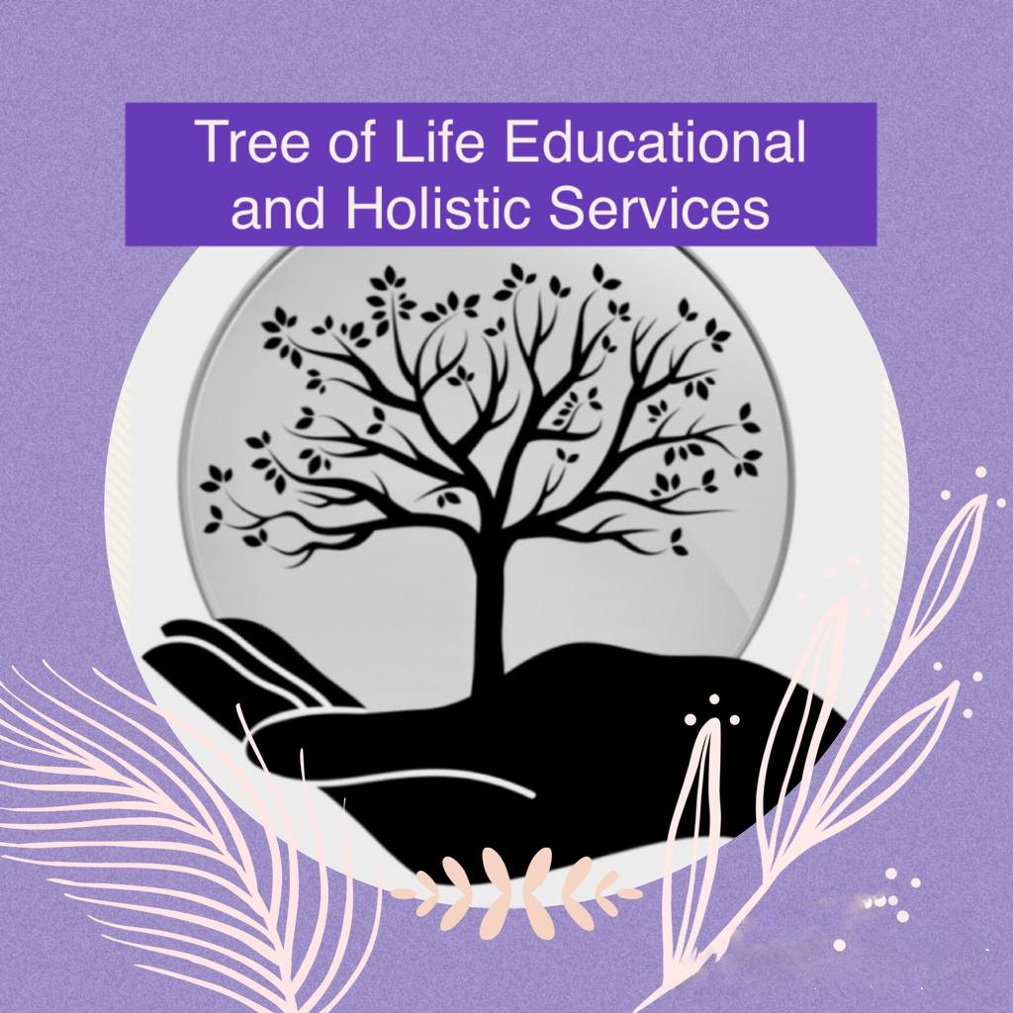

**Quality Assurance Review**

**Original - February 2024**

**Updated – September 2024**

**Reviewed Annually**

Tree of Life will use the marking criteria and assessment policies from the given awards in order to deliver the unit/qualification. We will use Solar Systems to monitor the individual learner’s progress.

In our learner’s portfolios there will be sufficient evidence to prove that the individual has completed a unit/qualification.

Tree of Life Educational and Holistic Services CIC will use knowledge, skills and relevant materials to deliver the unit/course required. We will review the course regularly and update materials as necessary.

Tree of Life Educational and Holistic Services CIC can demonstrate learners’ progress by continuously updating learners portfolios in line with Solar Systems.

Tree of Life Educational and Holistic Services CIC will retain evidence for 3-5 years.

Tree of Life will prepare for a quality review visit by ensuring that all relevant paperwork is up to date, any reviews have been documented and learners portfolios have been assessed.

**Learner Review and Feedback**

The learner's voice is an important part of course development.  Each learner will have the opportunity to have feedback and give feedback on their learning by attending regular reviews and completing unit/course feedback forms. Learners will also be given the opportunity to meet with Internal Verifiers (IV) and External Verifiers (EV) where possible.

It is expected that course resources will be reviewed and revised accordingly at the end of each programme of learning, based on learner feedback and course team feedback.