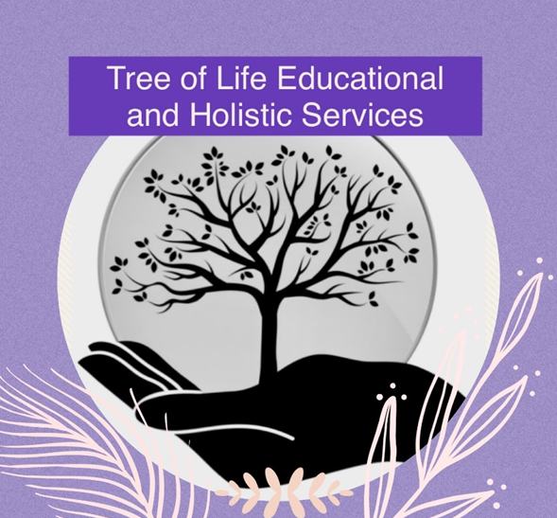

**Equal Opportunities and Diversity Policy**

**Original - August 2022**

**Updated – September 2024**

**Reviewed Annually**

This policy describes the way in which Tree of Life will meet the requirements of the Equality Act 2010. This act replaces all previous legislation such as the Race Relations Act, the Disability Discrimination Act and the Sex Discrimination Act. The policy will be applied to all staff and pupils, as well as any volunteers working in the provision.

**Rationale**

Tree of Life is committed to the principles of equality, respect, fairness and justice. Tree of Life will adhere to the Equality Act 2010 by not discriminating against learners, staff, volunteers or anyone involved in external agencies the school may be working with on the grounds of any of the protected characteristics (as defined by the Equalities Act). These include: age, disability, gender reassignment, marriage and civil partnership, pregnancy and maternity, race, religion and belief, sex and sexual orientation. We seek to treat all members of the school community equally regardless of any protected characteristics and it is expected that every person in the provision (as named above) will make a positive contribution to this policy.

**Our aims are:**

* To promote the principles of equality, respect, fairness and justice for all
* To develop universal values and world citizenship by celebrating cultural diversity

and supporting pupils in developing a positive self-image

* To provide pupils with equal access to the full range of learning opportunities
* To promote good relations between persons of different racial groups, challenging

stereotyping and prejudice and acting promptly to remove any forms of direct or

indirect discrimination

* To ensure that all recruitment, employment, promotion and training systems are

fair to all, and provide opportunities for everyone to achieve

**The role of the Head of Education is:**

* To implement and review our equal opportunities and diversity policy, updating it as necessary
* To ensure that all the members of the school community are aware of and implement the policy
* To ensure that the policy is implemented with regard to staff selection and appointments

**Tree of Life will:**

* Take seriously reports of discrimination from parent/carers, pupils or staff by investigating them and ensuring that appropriate action is taken

**The role of shared Head’s**

The role of Head of Education and of Holistic Therapies have crucial roles ensuring all staff are providing equal opportunities for all children and enabling children to develop universal values that encompass the principles of equality, respect, fairness and justice. All staff must ensure all children are treated fairly, equally and with respect. When devising curriculum policies and plans and selecting resources, learning mentors must strive to provide material that is not sexist or racist and which gives positive images of ethnic minorities and challenges stereotypical images.

**Action in cases of discrimination against pupils:**

* Staff must challenge incidents of prejudice or discrimination
* Staff must make a written record of serious incidents and report them to Tree of Life Education leads

**Minor incidents of discrimination**

For younger children it may be effective to use role-play, story and puppets to demonstrate appropriate behaviour and language. Discussion with the pupil and the support of parents may be sufficient to change attitudes and behaviour. Serious incidents of discrimination (See appendix 2). Serious incidents involving pupils are dealt with under the school’s Behaviour Policy.

**Discrimination against staff**

If a member of staff believes that they have been subject to discrimination they should report the matter to Tree of Life. Tree of life leads will make a record of the interview with the member of staff and both will sign it as an accurate record immediately. Tree of life leads are responsible for conducting an investigation within eight working days and informing those concerned of the outcome. Disciplinary procedure is then followed if a member of staff is found to be in breach of the school’s Equal Opportunities and Diversity policy.

**Appendix 1 - Definition of Discrimination**

* Discrimination in recruitment is unlawful and can be identified as direct/indirect discrimination, harassment, segregation and victimisation. Health related questions will not be asked until after a job offer is made, and then, only if it is necessary for the role
* Direct discrimination occurs when a person or group is treated less favourably than others are or would be treated in the same or similar circumstances e.g. pregnant women or new mothers
* Indirect discrimination involves the inclusion of a condition or a requirement which adversely affects applications from a large proportion of persons
* Harassment consists of any repeated and unwanted comments, looks, suggestions or physical contact that a person finds objectionable and offensive and causes them discomfort at work
* Segregation is unlawful and occurs when a person or group of people are kept separate from others on the basis of their particular race or sex
* Victimisation is unlawful and occurs where a person is treated less favourably than others would be in the same circumstances

**Appendix 2 - Examples of serious incidents:**

a) A physical assault against a person or group because of ethnicity, gender or disability

b) Verbal abuse, derogatory name calling, insults, threats or jokes targeting an individual’s race, sexuality or disability

c) Issuing/wearing of racist materials e.g. leaflets, magazines, insignia

d) Inciting others to discriminatory behaviour

e) Making repeated unacceptable comments or suggestions in the course of

discussions or lessons

f) Refusing to cooperate with colleagues or pupils because of colour, sexuality,

disability, ethnic origin or religion

g) Excluding pupils from activities, or recruiting and selecting in preferential ways

**Procedure For Managing a Breach of Equal Opportunities Policy**

**Step 1**

Any person who experiences, witnesses or is reasonably led to believe that this Equal Opportunities Policy has not been respected, should immediately bring the situation to the attention of Laura Frain, Head of Education. The person responsible for this breach will be reminded of the existence and purpose of this policy and asked to adhere to the policy.

**Step 2**

If the person continues behaving in an unacceptable manner, the matter will be referred to both shared Head’s who will decide the best course of action.

This may result in a warning being issued or a disciplinary.

**Step 3**

The offending person has a right to appeal. He/she/they can write to the trustees whereby a hearing will be held to reach a final decision.